Zoom Info
OWEN 102

Room System
- Log into the installed computer and turn on the in-room technology system using the Crestron panel.

Note: To use the classroom technology for remote instruction in Zoom, you must use the installed computer. A personal device will not work with the installed camera and microphones.

2. Once the system has turned on, select COMPUTER or PC on the Crestron panel.
3. Login to Canvas then navigate to your zoom link.
4. Select JOIN WITH COMPUTER AUDIO.

Note: Source names in Zoom can vary by classroom, so we recommend testing

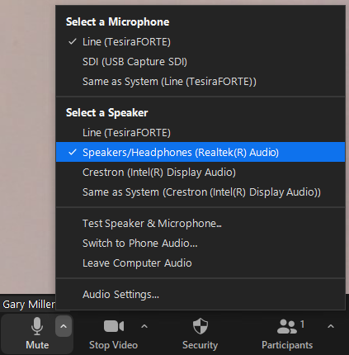
5. Speaker: ”Speakers/Headphones(Realtek® Audio)”
Figure 1
Microphone: “Line (TesiraFORTE)” (Figure 1)

6.Test the audio using the TEST SPEAKER AND MICROPHONE option.

7. Double check that your remote students can see and hear you, and you can hear them in the classroom.

8. Share your screen.

9. Start your lecture.

Slides from Laptop or Tablet

- Steps 1 -7 from “Room System” above.
- Connect your laptop or tablet to the same zoom meeting.
- Don’t connect audio or video, you’ll use the room hardware.
  - If connected disconnect or mute both your mic and speakers on the device.
- Share your screen.
- Start your lecture.

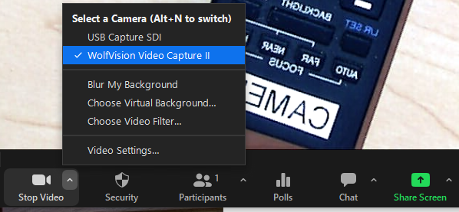
Document Camera
Figure 2
- Steps 1 -7 from “Room System” above.
- Choose a new camera source, not share screen.
  - WolfVision Video Capture II (figure 2)
- If the image is backward, like in this example.
  - Uncheck the Mirror my Video box under Video settings. (Figure 3)
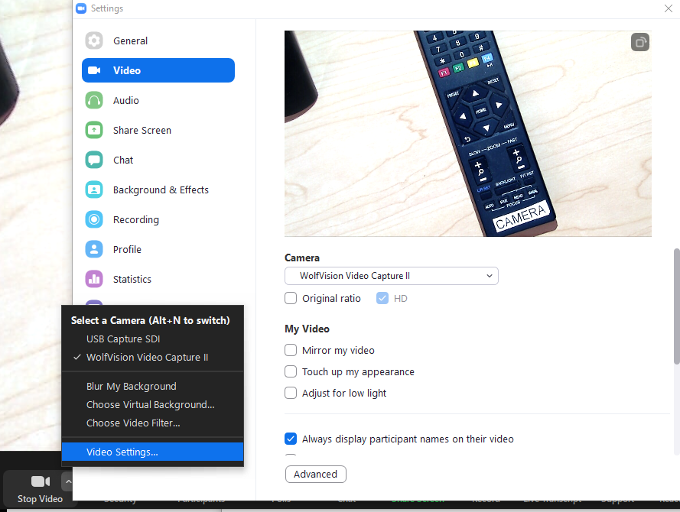

Figure 3
Windows Presentation Mode
Figure 4
- Press the Windows Key + P to open the Presentation Mode option on the right side of your screen. (Figure 4)

Duplicate is usually the default option; this make it simple to share if you don’t need the Presenter View in Powerpoint.

To use Presenter View Powerpoint
- Change the Windows Presentation Mode to Extended
- Share the Desktop the PowerPoint presentation will be displayed on, usually Screen or Window 2. (Figure 5)
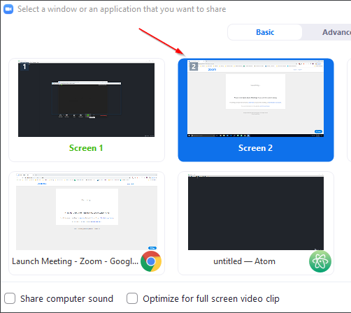
Figure 5

